

AMERICAN INTERNATIONAL UNIVERSITY–BANGLADESH (AIUB)
FACULTY OF SCIENCE & TECHNOLOGY
DEPARTMENT OF PHYSICS
PHYSICS LAB 5
Fall 2023-2024

LAB REPORT ON
Determination of the temperature coefficient of resistance of the material of a wire

Supervised by,
DR. KAMRUN NAHAR MUKTA
Submitted By
S. N. | Name | ID | Contribution
1 | Farhan Chowdhury | 23-52314-2 | Experimental Data,  Discussion, Theory
2 | Nayem Siddiki | 23-52361-2 | Theory, Discussion, Reference, Calculation
3 | Fahim Al Noor | 23-51977-2 | Analysis, Discussion,  Result, Theory
4 | Amanur Rahman | 23-52039-2 | Procedure, Discussion, Reference, Theory
5 | Mubashshirul Islam | 23-52322-2 | Apparatus, Result,  Discussion

Submission: 23 July 2023

TABLE OF CONTENTS

Topic | Page no
Title Page | 1
Table of Contents | 2
- Theory | 3
- Apparatus | 5
- Procedure | 5
- Experimental Data | 6
- Calculations | 7
- Result | 7
- Discussion | 7
- Reference | 7

- Theory:
The determination of the temperature coefficient of resistance (TCR) of a wire involves measuring how the electrical resistance of the wire changes with temperature. This is crucial as different materials exhibit varying degrees of resistance changes with temperature fluctuations. To determine the TCR, the wire's initial resistance and temperature are measured at a starting point, usually at room temperature. Then, controlled heat is applied to the wire to raise its temperature while continuously measuring the resistance at specific temperature intervals. By calculating the ratio of the change in resistance to the change in temperature, the TCR can be obtained. A positive TCR value indicates an increase in resistance with temperature, while a negative value signifies a decrease in resistance with temperature. This experiment is essential for understanding and predicting the behavior of wires and other electronic components under varying temperature conditions, aiding in the design and functionality of electronic devices and system.
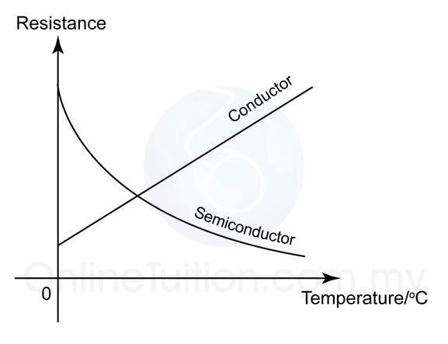
Figure 1: A graph that shows the changes in resistances of a conductor and a semiconductor with temperature. For conductor the resistance increases linearly and for semiconductor the resistance decreases exponentially with the temperature.
For a conductor the resistance increases with increase of temperature, as the figure 1 shows. If R₁ is the resistance of a conductor at temperature θ₁ and at a higher temperature θ₂ the resistance raises to R₂, then we can write:
𝑹_{𝟐} = 𝑹_{𝟏}[𝟏 + 𝜶 (𝜽_{𝟐} − 𝜽_{𝟏})]
𝒐𝒓, 𝑹_{𝟐} = 𝑹_{𝟏} + 𝑹_{𝟏}𝜶 (𝜽_{𝟐} − 𝜽_{𝟏})  𝒐𝒓, 𝑹_{𝟏}𝜶 (𝜽_{𝟐} − 𝜽_{𝟏}) = 𝑹_{𝟐} − 𝑹_{𝟏}  𝒐𝒓, 𝜶 = 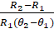  or, 𝜶 = 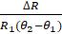 | Here,  𝜶 = temperature coefficient of the material of the conductor.  ∆𝑅 = change in resistance due to the change in temperature ∆𝜃.
Taking 𝑅₁ = 1 Ohms & ∆𝜃 = 1 ⁰C we get 𝛼 = ∆𝑅, thus we define the temperature coefficient of resistance of a substance as the change in resistance per unit resistance (per ohm) for unit change in temperature (per ⁰C). Also, we find the unit of 𝛼 as per ⁰C.
For a conductor, if we know the resistances R₁ at a temperature θ₁ and R₂ at a higher temperature θ₂, then we can calculate the temperature coefficient of resistance of its material by using the equation:
𝜶 =

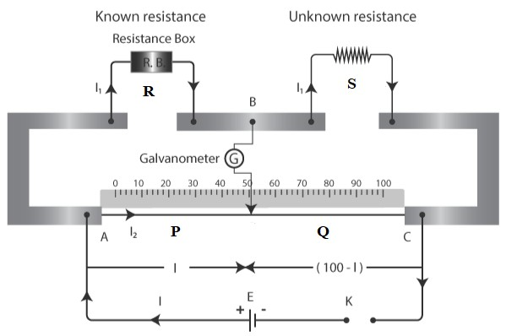
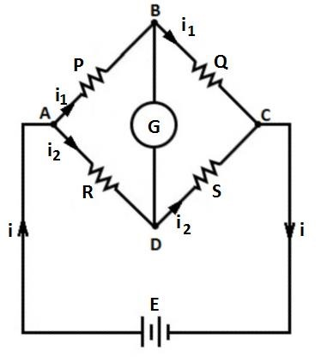
The unknown resistance can be determined by a meter bridge that works with the Wheatstone bridge principle.

Figure 2: A meter bridge used to determine Figure 3: The Wheatstone Bridge
an unknown resistance by using the Wheatstone bridge principle.
In the meter bridge circuit as in figure 3, for the null deflection in the galvanometer we get,
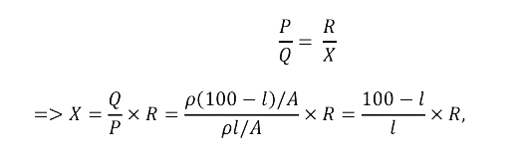

According to above equation, if we know the length of the balance point, l and the resistance, R we can determine the unknown resistance S.
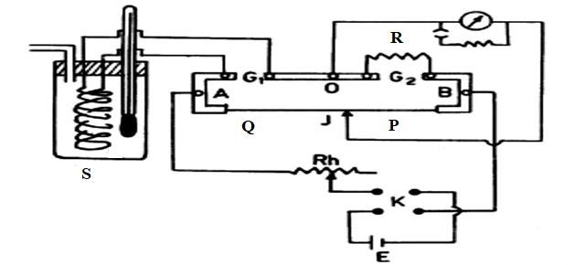

Figure 4: Circuit Diagram for the experiment

- Apparatus:

- Power Supply
- Meter Bridge
- Galvanometer
- Jockey, Resistance Box
- Coil of conducting wire
- Thermometer
- Water, Electric heater
- Commutator Beaker

- Procedure

The figure 4 apparatus was utilized as follows:
- Initially, the coil of wire was connected to the left gap (𝐺1) and placed inside the beaker at room temperature. 𝜃1 from the thermometer was recorded. Subsequently, the resistance box was linked to the right gap (𝐺2) of the meter bridge. The flow of electricity through the circuit was altered by manipulating the knobs in different positions of the commutator. Various resistances (e.g., 5, 7, 9 Ohms) from the resistance box were employed, and the equilibrium positions on the meter bridge were identified. The measurements for the reverse current were also recorded.

- The positions of the resistance box and the coil of wire were interchanged on the meter bridge gaps. Direct and reverse current readings for identical resistances (e.g., 5, 7, 9 Ohms) were also documented.

- The temperature within the beaker was elevated by introducing hot water. The elevated temperature (𝜃2) was noted using the thermometer. The equilibrium points for the same resistances (e.g., 5, 7, 9 Ohms) were once more determined for both direct and reverse currents, considering connections of the coil of wire to the right and left gaps of the meter bridge.

- The value of the unknown resistance was determined for both left and right gaps. Additionally, the temperature coefficient (α) was calculated

- Experiment Data:
Table – 1: Readings of balance points on Meter Bridge.
Temperature  (  0  C) | Known  Resistance,  R (Ohms) | Position of  Unknown  Resistance,  S | Position of balance point, l (cm) |  | Mean of l (cm) | 100 – l  (cm) | S (Ohms) | Mean of S  (Ohms)
Temperature  (  0  C) | Known  Resistance,  R (Ohms) | Position of  Unknown  Resistance,  S | Direct current | Reverse current
𝜃  1  =  24℃ | 5 | Left | 58.2 | 59.1 | 58.65 | 41.35 | 3.53 | X₁= 6.35 Ω
𝜃  1  =  24℃ | 5 | Right | 49.5 | 50.5 | 50 | 50 | 5 | X₁= 6.35 Ω
𝜃  1  =  24℃ | 7 | Left | 52.5 | 51.9 | 52.2 | 47.8 | 6.41 | X₁= 6.35 Ω
𝜃  1  =  24℃ | 7 | Right | 54.5 | 51.8 | 53.15 | 46.85 | 6.17 | X₁= 6.35 Ω
𝜃  1  =  24℃ | 9 | Left | 47.3 | 45.5 | 46.4 | 53.6 | 10.39 | X₁= 6.35 Ω
𝜃  1  =  24℃ | 9 | Right | 59.3 | 55.9 | 57.6 | 42.4 | 6.63 | X₁= 6.35 Ω
𝜃  2  =  80℃ | 5 | Left | 58.1 | 56.1 | 57.1 | 42.9 | 3.76 | X₂= 6.84 Ω
𝜃  2  =  80℃ | 5 | Right | 44.5 | 40.2 | 42.35 | 57.65 | 6.81 | X₂= 6.84 Ω
𝜃  2  =  80℃ | 7 | Left | 56.9 | 50.7 | 53.8 | 46.2 | 6.01 | X₂= 6.84 Ω
𝜃  2  =  80℃ | 7 | Right | 46.7 | 49.6 | 48.15 | 51.85 | 7.54 | X₂= 6.84 Ω
𝜃  2  =  80℃ | 9 | Left | 54.3 | 45.4 | 49.85 | 50.15 | 9.05 | X₂= 6.84 Ω
𝜃  2  =  80℃ | 9 | Right | 52.6 | 54.1 | 53.35 | 46.65 | 7.87 | X₂= 6.84 Ω
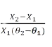
- Calculation:
Temperature coefficient of resistance, α =
= 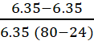
= 1.378 x 10⁻³ C⁻¹
- Result:
Temperature | Resistance (ohm) | Temperature coefficient of resistance (/⁰C)
𝜃₁ = 24 | X₁ = 6.36 | 1.378 x 10⁻³ C⁻¹
𝜃₂ = 80 | X₂ = 6.67 | 1.378 x 10⁻³ C⁻¹

- Discussion:

The experiment aimed to determine the temperature coefficient of resistance (TCR) of a wire's material. The wire's resistance was measured at different temperatures using a multimeter. The temperature was controlled and varied systematically during the experiment. By plotting the resistance versus temperature data and calculating the slope of the graph, the TCR was obtained. This coefficient indicates how much the wire's resistance changes with temperature, providing valuable information for practical applications and understanding the wire's behavior under different conditions.

- References:
    - Fundamental of Physics (10th Edition): Resistance and resistivity (Chapter 26, page-755)
- Video Links:
    - Temperature coefficient: https://www.youtube.com/watch?Tgm 0f2mOs
    - Meter Bridge: https://www.youtube.com/watch?venqx8vIdHVKQ

